Deploying an S3 Bucket
terraform-course/projects/proj01-s3-static-website.md at main · lm-academy/terraform-course

Create a new subdirectory for this lab
Create 2 Terraform configuration files

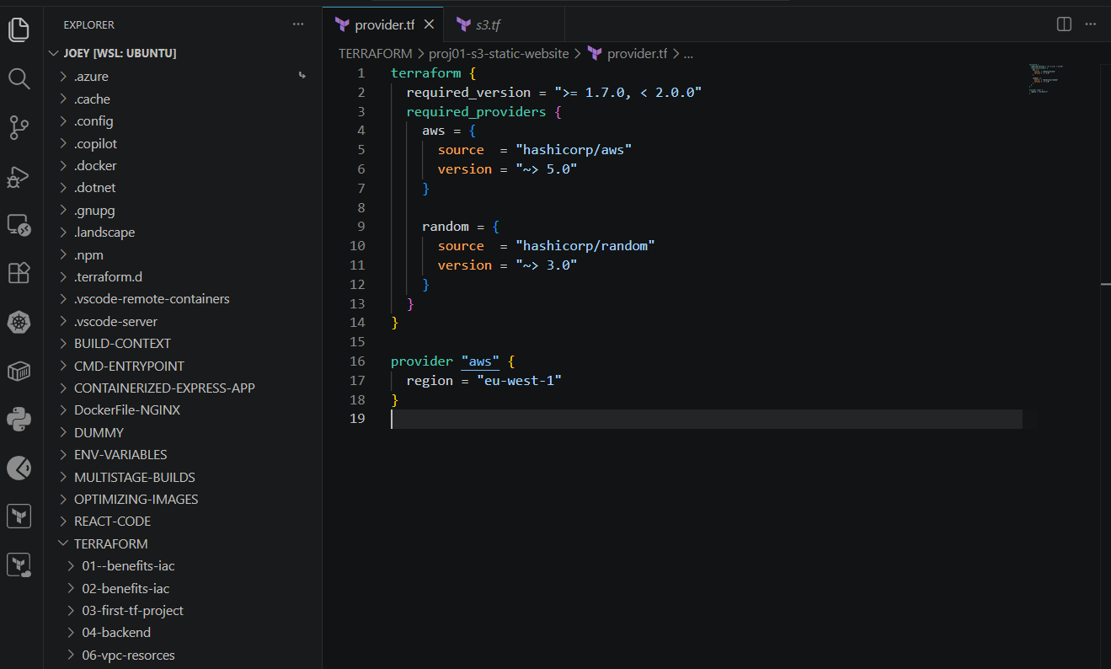

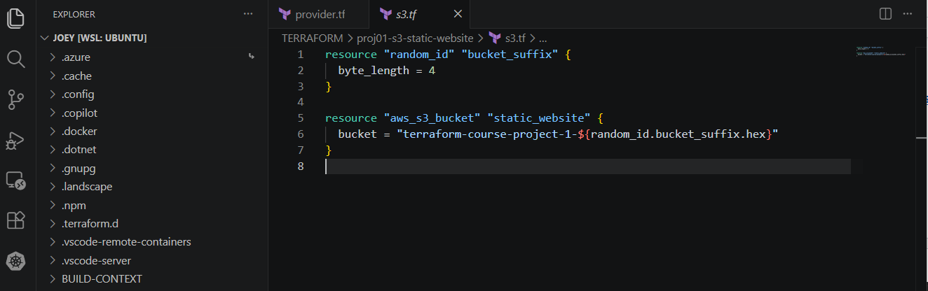

Note: Configuring multiple providers
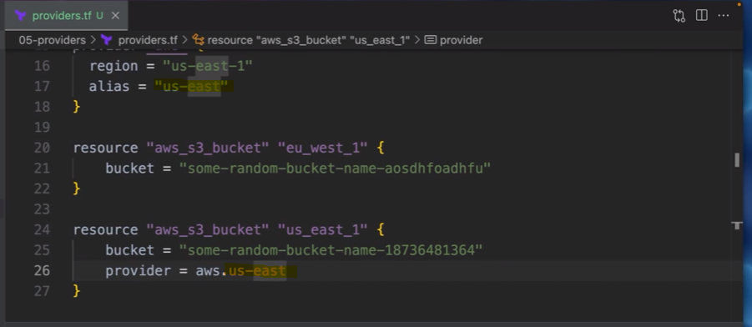

Public Access Block

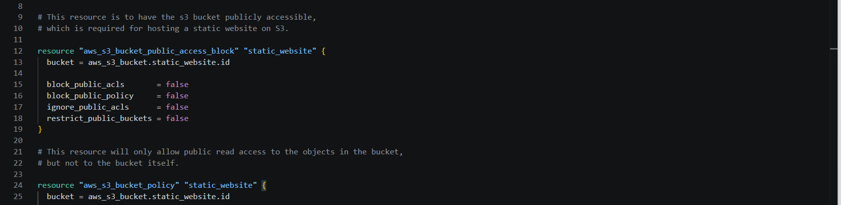

Documentation
aws_s3_bucket_public_access_block | Resources | hashicorp/aws | Terraform | Terraform Registry
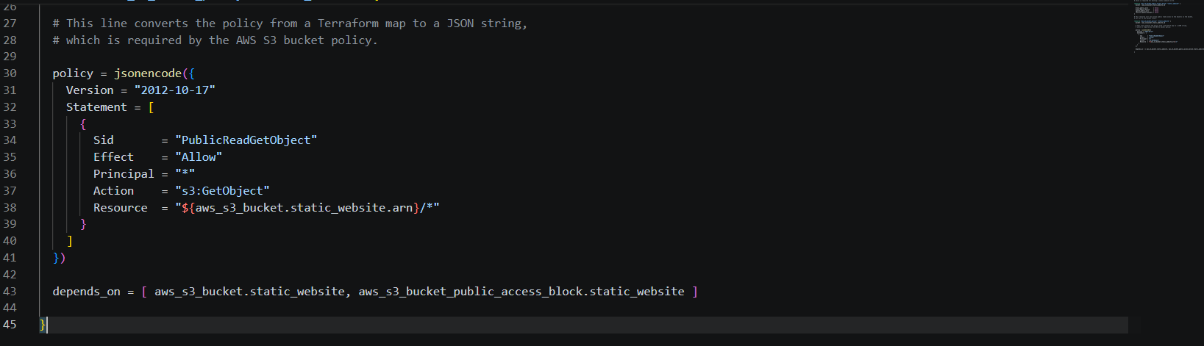

The code above converts the HCL code to json
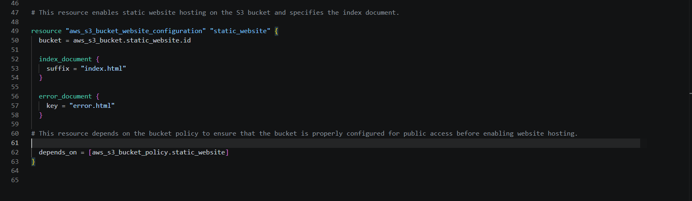

Initialize these configuration files
terraform init

Run plan command
terraform plan

Apply the plan
terraform apply

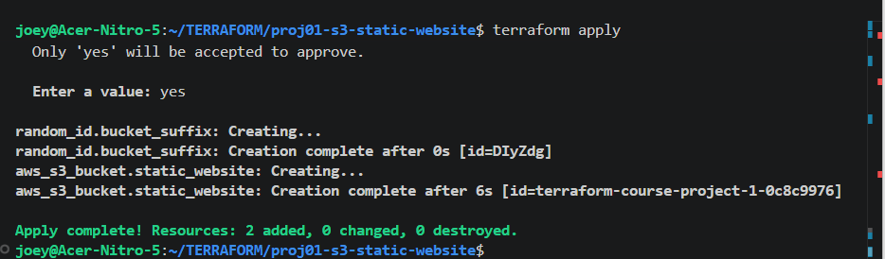

In this stage, S3 Bucket is created but not yet configured as static S3 website

Upload the 2 html files manually first to the static S3 bucket and check if the static page works. Click on the link shown is AWS console

Uploading Files to S3 via Terraform using s3.tf file

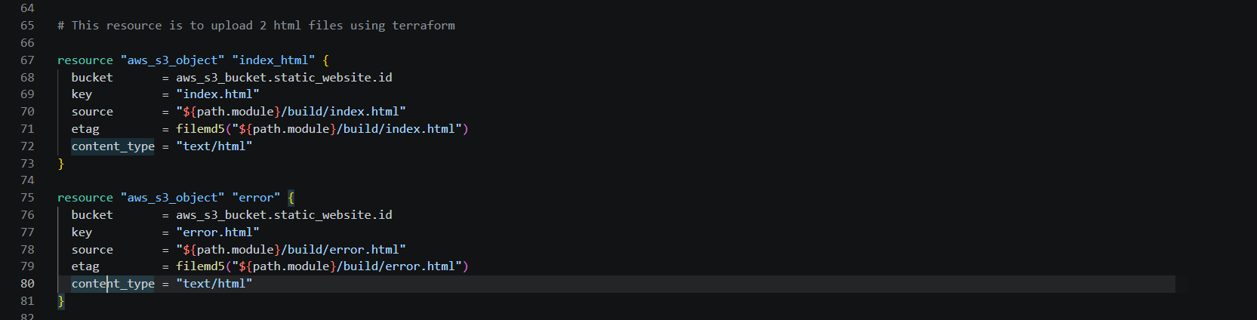

To expose the website endpoint that we can reach out to visualize our website
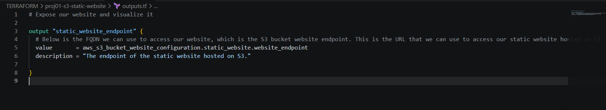

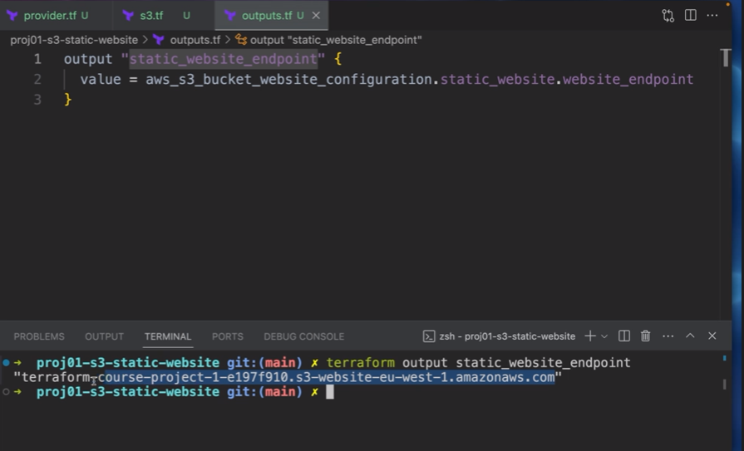

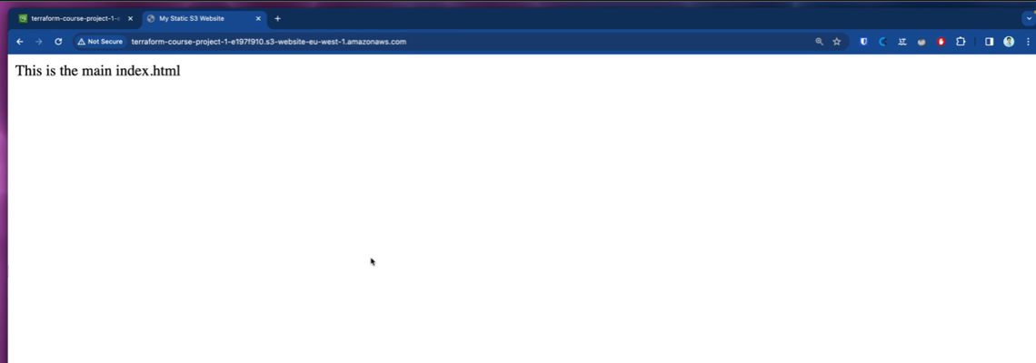

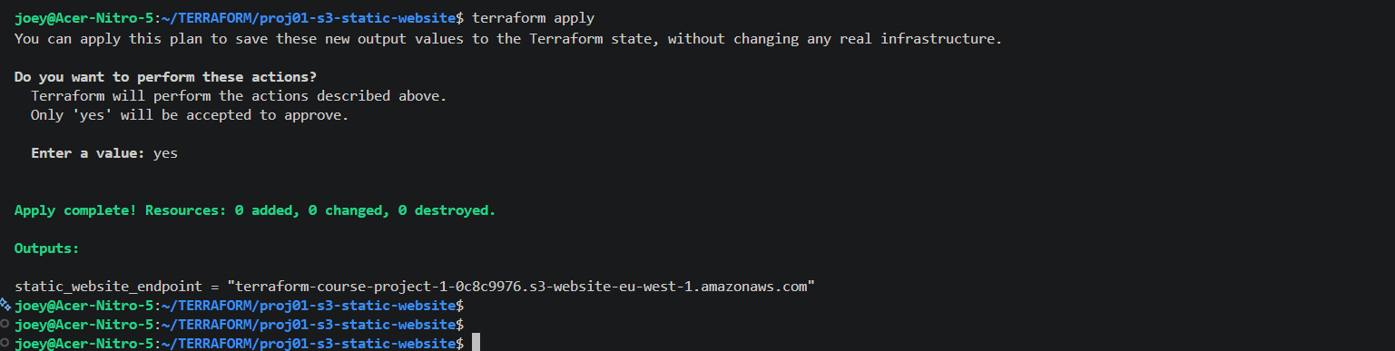

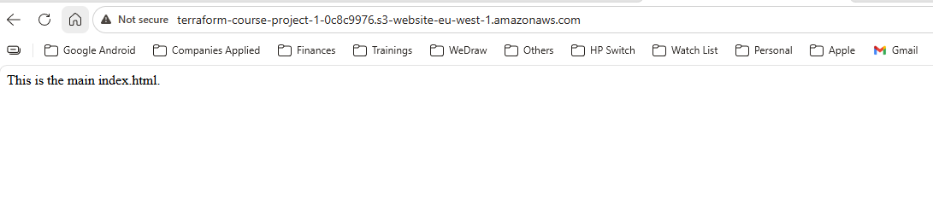


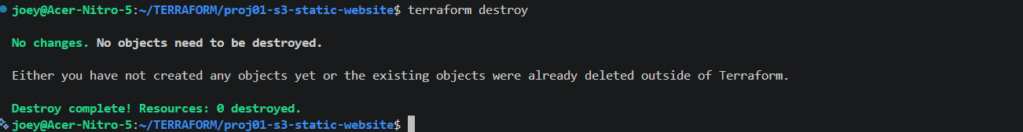

NOTE: If the objects were uploaded manually you will get an error saying the bucket is not empty. But if everything was configured using terraform, when you destroy it you will see the following where terraform deletes the object first before deleting the s3 bucket



